Grade 6 MCA-III – Test #9 Answers

1. | 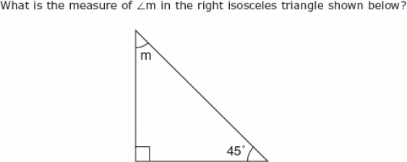
 | a. | 35º
 | b. | 45º
 | c. | 90º
 | d. | 180º

Correct Answer: | 45º

Explanation
The sum of the measures of the interior angles of a triangle is 180 degrees and the measure of a right angle is 90 degrees. We can subtract the measures of the two angles given from 180 degrees to find the measure of angle m: 180 - 90 - 45 = 45 degrees. Interior Angles of Polygons / Geometry & Measurement

2. | The picture below is a scale drawing of a rectangular bulletin board. Use a ruler to measure the dimensions of the scale drawing to the nearest inch.  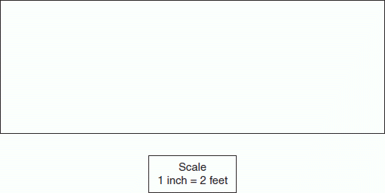  Which of the following is closest to the perimeter in feet of the actual bulletin board?
 | a. | 32 ft
 | b. | 76 ft
 | c. | 16 ft
 | d. | 48 ft

Correct Answer: | 32 ft

Explanation
The perimeter of a polygon is the sum of the lengths of all its sides. By using a ruler we can see that the length of the sides of this rectangle are 5.5 inches, 5.5 inches, 2 inches, and 2 inches. If we add those numbers together we get: 5.5 + 5.5 + 2 + 2 = 15 inches. Since 1 inch equals 2 feet, we can multiply that number by 2: 15 x 2 = 30 feet. Therefore, 32 feet is the closest to the perimeter of this bulletin board. Perimeter / Geometry & Measurement

3. | Use the illustration below to answer this question.  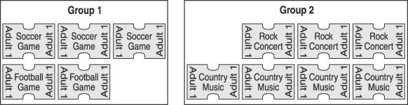  Donny must select one ticket at random from each group of tickets shown above. What is the probability that he will select a football ticket and a country music ticket?
 | a. | 1  2
 | b. | 1  35
 | c. | 8  21
 | d. | 8  35

Correct Answer: | 8  35

Explanation
The probability of an outcome for a particular event is a number telling us how likely a particular outcome is to occur. This number is the ratio of the number of ways the outcome may occur to the number of total possible outcomes for the event. The probability of picking a football ticket from Group 1 is 2/5 and the probability of picking a country music ticket from Group 2 is 4/7. We can multiply the probabilities together to determine the probability of choosing both: 2/5 x 4/7 = 8/35. Theoretical Probability / Data Analysis & Probability

4. | Which exponential notation represents the number 32?
 | a. | 8⁴
 | b. | 2¹⁶
 | c. | 2⁵
 | d. | 1³²

Correct Answer: | 2⁵

Explanation
The exponential notation 2⁵ is 2 x 2 x 2 x 2 x 2. If we compute the multiplication we get: 2 x 2 = 4, 4 x 2 = 8, 8 x 2 = 16, and 16 x 2 = 32. Exponents / Algebra

5. | In Tom’s class, 20 of the 25 students got a perfect score on a test. What percent of the students got a perfect score?
 | a. | 0.80%
 | b. | 20%
 | c. | 25%
 | d. | 80%

Correct Answer: | 80%

Explanation
We need to know what percentage of 25 that 20 represents. Divide the first number by the second: 20 ÷ 25 = 0.80. Multiply the answer by 100 (move decimal point two places to the right): 0.80 * 100 = 80.0. Follow the answer with the % sign: 20 is 80% of 25. Determining Percentage / Number & Operation

6. | If x = 4 and y = 3, then xy − 2x =
 | a. | 4
 | b. | 6
 | c. | 19
 | d. | 40

Correct Answer: | 4

Explanation
If we substitute 4 for x and 3 for y in this expression we get: (4)(3) - 2(4). According to the order of operations, multiplication and division must be completed before addition and subtraction. If we do the multiplication we get: 12 - 8 = 4. Multiple Variable Equations / Algebra

7. | 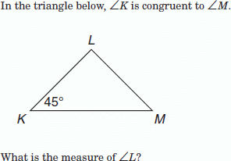
 | a. | 45°
 | b. | 180°
 | c. | 135°
 | d. | 90°

Correct Answer: | 90°

Explanation
The sum of the measures of the interior angles of a triangle is 180 degrees. Since angle K is congruent to angle M, then angle M equals 45 degrees. We can add those measures together and subtract that from 180 degrees to find the measure of angle L: 180 - (45 + 45) = 180 - 90 = 90 degrees. Interior Angles of Polygons / Geometry & Measurement

8. | A parallelogram has a base of 25 centimeters and a height of 8 centimeters. What is the area?
 | a. | 100 cm²
 | b. | 200 cm²
 | c. | 300 cm²
 | d. | 400 cm²

Correct Answer: | 200 cm²

Explanation
The area of a parallelogram is b × h, where b is the length of the base of the parallelogram, and h is the corresponding height. If we plug our numbers into the formula we get: A = 25 x 8 or A = 200 cm². Area of a Parallelogram / Geometry & Measurement

