Grade 6 MCA-III – Test #7 Answers

1. | A square and a rectangle are shown.  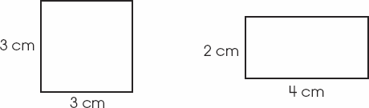  Which statement is true about these two figures?
 | a. | They have the same area and the same perimeter.
 | b. | They have different areas and the same perimeter.
 | c. | They have the same area and different perimeters.
 | d. | They have different areas and different perimeters.

Correct Answer: | They have different areas and the same perimeter.

Explanation
If l is the side-length of a square, the area of the square is l² or l × l. The area of this square is: 3 x 3 = 9. The area of a rectangle is the product of its width and length. The area of this rectangle is: 2 x 4 = 8. The perimeter of a polygon is the sum of the lengths of all its sides. The perimeter of this square is: 3 + 3 + 3 + 3 = 12. The perimeter of this rectangle is: 2 + 2 + 4 + 4 = 12. Therefore, these figures have different areas and the same perimeter. Area and Perimeter / Geometry & Measurement

2. | The table below shows the bowling scores of 125 students.  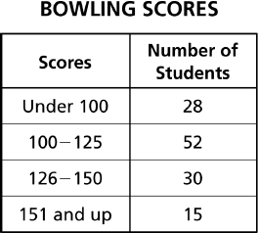  What is the experimental probability that the next student who bowls will have a score that is 126 or more?
 | a. | 15  125
 | b. | 30  125
 | c. | 45  125
 | d. | 80  125

Correct Answer: | 45  125

Explanation
For experimental probability we calculate the 'relative observed frequencies' of an event. We divide the number of occurrences of the event by the number of trials. Since there are 45 scores of 126 or more, and there are 125 total scores, the experimental probability of the next student bowling a score of 126 or more is 45/125. Experimental Probability / Data Analysis & Probability

3. | Simplify the expression below.  4³
 | a. | 7
 | b. | 12
 | c. | 43
 | d. | 64

Correct Answer: | 64

Explanation
The expression 4³ is equivalent to 4 x 4 x 4, which equals 64.: Exponents / Number & Operation

4. | On a recent trip, Stephan traveled a total of 9 1/2 hours at an average speed of 57 miles per hour. What was the total distance he traveled on the trip?
 | a. | 513.5 miles
 | b. | 518.7 miles
 | c. | 524.4 miles
 | d. | 541.5 miles

Correct Answer: | 541.5 miles

Explanation
To multiply a mixed number by a whole number, convert the mixed number to an improper fraction: 9 1/2 = 19/2. Place a 1 as the numerator of the whole number and multiply the two numerators together: 19 x 57 = 1083. Multiply the two denominators together: 2 x 1 = 2. Now we have the fraction 1083/2, which reduces to 541.5 miles. Multiplying Mixed Numbers / Number & Operation

5. | If $55 of a $220 budget is spent on clothes, what percent of the budget is spent on clothes?
 | a. | 25%
 | b. | 55%
 | c. | 85%
 | d. | 95%

Correct Answer: | 25%

Explanation
We need to find out what percentage 55 represents of 220. Divide the first number by the second: 55 ÷ 220 = 0.25. Multiply the answer by 100 (Move decimal point two places to the right): 0.25 * 100 = 25. Follow the answer with the % sign: 25%. Determining Percentage / Number Sense & Operation

6. | 2 × 2 × 5 shows the prime factorization of what number?
 | a. | 10
 | b. | 12
 | c. | 20
 | d. | 100

Correct Answer: | 20

Explanation
A prime number is a number whose only factors are itself and 1. Prime factorization is the list of all the prime-number factors of a given number. The prime factorization of 20 is 2 x 2 x 5 because all the factors are prime numbers. Prime Factorization / L to L: Number & Operation

7. | At West Elementary School, there are exactly 3 boys for each girl in every class. If b is the number of boys and g is the number of girls, the equation b = 3g can be used to show this relationship. According to this equation, how many boys are in a class that has 6 girls?
 | a. | 6
 | b. | 16
 | c. | 18
 | d. | 72

Correct Answer: | 18

Explanation
If we substitute 6 into the equation for g we get: b = 3(6) or b = 18. Click Algebra Word Problems / Algebra

8. | Which equation best represents the relationship between x and y in the table below?  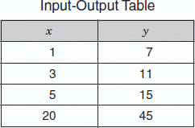
 | a. | y = 7x
 | b. | y = 3x + 4
 | c. | y = 2x + 5
 | d. | y = x + 6

Correct Answer: | y = 2x + 5

Explanation
The equation of a straight line in the "slope-intercept" form is: y = mx + b, where m is the slope and b is the y-intercept. To find the slope we use the following formula: m = y₁ - y₂ / x₁ - x₂. If we pick two points from the table and plug them into the formula we get: m = 7 - 11 / 1 - 3 = -4 / -2 = 2. Now we can plug the slope and one point from the table into the formula and solve for b: 7 = 2(1) + b. If we do the multiplication we get: 7 = 2 + b. If we subtract 2 from both sides we get: 5 = b. Therefore, the equation that represents this data is: y = 2x + 5. Straight Line Equations / Algebra

