Grade 6 MCA-III – Test #5 Answers
1. | Two number cubes, each with sides numbered 1 through 6, are rolled at the same time.  What is the probability of rolling a number greater than 4 on both number cubes?
 | a. | 1  36
 | b. | 1  9
 | c. | 1  3
 | d. | 2  3

Correct Answer: | 1  9

Explanation
The probability of an outcome for a particular event is a number telling us how likely a particular outcome is to occur. This number is the ratio of the number of ways the outcome may occur to the number of total possible outcomes for the event. If there are 2 cubes with 6 sides each, there are 36 total possible outcomes (6 x 6). Since 5 and 6 are greater than 4 on both cubes, there are 4 possible ways to draw a number greater than 4. Therefore, the probability of rolling a number greater than 4 on both cubes is 4/36 or 1/9. Probability of an Outcome / Data Analysis & Probability

2. | Each square below is divided into sections of equal size. Which square has 62.5% of its total area shaded?
 | a. | 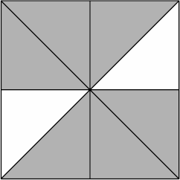
 | b. | 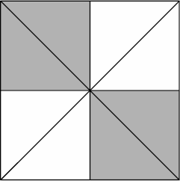
 | c. | 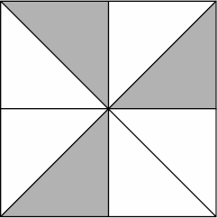
 | d. | 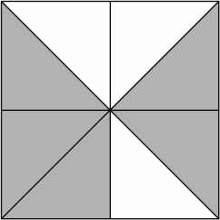

Correct Answer:

Explanation
To convert this percent to a fraction, turn the number into a decimal: 62.5% = 0.625. Since 5/8 = 0.625, answer D represents 62.5% of its total area shaded. Fractions, Decimals, and Percents / Number & Operation

3. | Find the greatest common factor of 12, 24, and 36.
 | a. | 6
 | b. | 12
 | c. | 18
 | d. | 24

Correct Answer: | 12

Explanation
The greatest common factor, or GCF, is the greatest factor that divides two or more numbers. To find the GCF of two numbers, list the factors of each number. The factors of 12 are 1, 2, 3, 4, 6, and 12. The factors of 24 are 1, 2, 3, 4, 6, 8, 12, and 24. The factors of 36 are 1, 2, 3, 4, 6, 9, 12, 18, and 36. Therefore, the greatest common factor of these numbers is 12. Greatest Common Factor / Number & Operation

4. | In Anne's rock collection, there are 32 quartz rocks. Fifteen of them are rose quartz and the rest are smoky quartz. What is the ratio of smoky quartz to rose quartz?
 | a. | 17 to 15
 | b. | 17 to 32
 | c. | 15 to 17
 | d. | 15 to 32

Correct Answer: | 17 to 15

Explanation
If there are 15 rose quartz rocks, then there are 17 smoky quartz rocks (32 - 15 = 17). Ratios tell how one number is related to another number. A ratio may be written as A:B or A/B or by the phrase "A to B". Therefore, the ratio of smoky quartz to rose quartz rocks is 17 to 15. Ratios / Ratio & Proportion / Geometry & Measurement

5. | What value for n makes the equation true?  3 x n = 1
 | a. | -3
 | b. | 1  3
 | c. | 2  3
 | d. | 2

Correct Answer: | 1  3

Explanation
We need to divide both sides of the equation by 3 to find the value of n: n = 1/3. Single Variable Equations / Number & Operation

6. | Look at the two right triangles below.  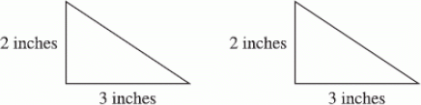  Which of the following rectangles has the same area as the area of the two right triangles combined?
 | a. | 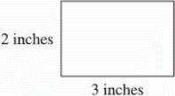
 | b. | 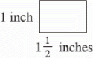
 | c. | 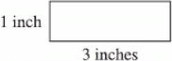
 | d. | 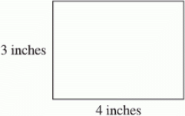

Correct Answer:

Explanation
The area of the rectangle should be twice the area of the two triangles since the triangles are the same size. However, the length of the sides of the rectangle should be the same as the length of the sides of the triangles. Therefore, answer A is correct. Area / Geometry & Measurement

7. | For triangle GXU, what is the value of the following expression?  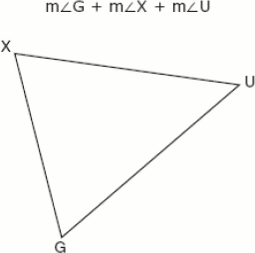
 | a. | 360º
 | b. | 180º
 | c. | 100º
 | d. | 90º

Correct Answer: | 180º

Explanation
The sum of the measures of the interior angles of a triangle is 180 degrees. Therefore, the value of this expression is 180 degrees. Interior Angles of Polygons / Geometry & Measurement

8. | An isosceles triangle has a perimeter of 44 feet. The base is 18 feet long. What is the length of each leg?  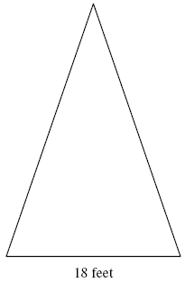
 | a. | 13 feet
 | b. | 18 feet
 | c. | 22 feet
 | d. | 26 feet

Correct Answer: | 13 feet

Explanation
An isosceles triangle is a triangle having two sides of equal length. If we know that the perimeter of this isosceles triangle is 44 feet and the base is 18 feet, we can subtract 18 from 44 to find the length of the legs together: 44 - 18 = 26. If we divide the 26 feet by 2 we can determine the length of each leg: 26 ÷ 2 = 13 feet Isosceles Triangle / Geometry & Measurement

