Grade 6 MCA-III - Test #3 Answers

1. | Which shows the meaning of 4³?
 | a. | 4 x 3
 | b. | 4 x 4 x 4
 | c. | 3 x 3 x 3 x 3
 | d. | 4 + 4 + 4

Correct Answer: | 4 x 4 x 4

Explanation
Exponents are used as a short way to represent a number. The exponent is the number of times the base is multiplied by itself. Therefore 4³ is equal to 4 x 4 x 4. What is an Exponent? / Number & Operation

2. | Mr. Lowery has 8 3/4 pounds of ground beef that he will use to make hamburgers for a picnic. What is the maximum number of quarter-pound hamburgers he can make?
 | a. | 9
 | b. | 17
 | c. | 35
 | d. | 36

Correct Answer: | 35

Explanation
We need to divide 8 3/4 by 1/4 to find out how many 1/4 pound hamburgers Mr. Lowery can make. To divide a mixed number by a fraction, convert the mixed number to an improper fraction: 8 3/4 = 35/4. Invert the fraction that is the divisor and multiply: 35/4 x 4/1 = 140/4. Convert the result back to a mixed number: 140/4 = 35 hamburgers. Dividing Mixed Numbers / Number & Operation

3. | Marissa said 90% of the 50 students in a school performance wore white shirts. What was the total number of students in the performance who wore white shirts?
 | a. | 100
 | b. | 50
 | c. | 45
 | d. | 25

Correct Answer: | 45

Explanation
To determine the percent of a number, multiply the number by the percent: 50 * 90 = 4500. Divide the answer by 100 (move decimal point two places to the left): 4500/100 = 45.00. Finding the Percent of a Number / Number & Operation

4. | Which expression shows the prime factorization of 112?
 | a. | 2³ x 7
 | b. | 2 x 7 x 8
 | c. | 2⁴
 | d. | 2⁴ x 7

Correct Answer: | 2⁴ x 7

Explanation
Prime factorization is the expression of a positive integer as a product of prime numbers. If the same prime factor occurs more than once, it can be written in exponential form. The prime factorization of 112 is 2 × 2 × 2 × 2 × 7. It can also be written as 2⁴ x 7. Prime Factorization / Number & Operation

5. | a + 59 = b: if a = 60; then b =
 | a. | 119
 | b. | 129
 | c. | 150
 | d. | 159

Correct Answer: | 119

Explanation
To solve this problem, substitute 60 into problem where you see a (60 + 59 = b). Therefore, b = 119. Click here for learning activities: Solving Equations / Algebra

6. | When asked to give the equation for the following line, four students gave different responses. Who correctly matched an equation with the graph?  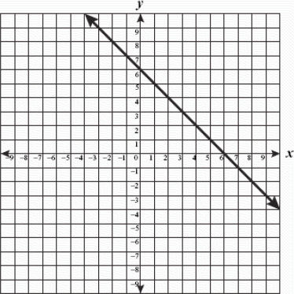
 | a. | Alice: y = ⁻x
 | b. | Bert: y = ⁻x + 6
 | c. | Carrie: y = x
 | d. | Don: y = x + 6

Correct Answer: | Bert: y = ⁻x + 6

Explanation
The equation of a straight line is y = mx + b, where the slope is the number m multiplied on x, and b is the y-intercept, where the line crosses the y-axis. We can see from the graph that this line crosses the y-axis at 6, so the y-intercept is 6. To find the slope of the line, pick two points on the line and plug them into the following formula: m = y₁ - y₂ / x₁ - x₂. If we pick points (0, 6) and (6, 0) and plug them into the formula we get: m = 6 - 0 / 0 - 6 = 6 / -6 = -1. Therefore, the slope is -1 and the formula for this line is: y = ⁻x + 6. Linear Equations: Algebra

7. | What is the value of the expression below?  20 − 3 × (2 + 4)
 | a. | 38
 | b. | 18
 | c. | 2
 | d. | 10

Correct Answer: | 2

Explanation
According to the order of operations, multiplication and division must be completed before addition and subtraction. Expressions in parenthesis are treated as one number and must be calculated first. Therefore, we must complete the calculation inside the parenthesis first: 2 + 4 = 6. Next we need to complete the multiplication 3 x 6 = 18. Now we can complete the subtraction: 20 - 18 = 2. Order of Operations / Algebra

8. | What is the measure of the missing angle in the diagram below?  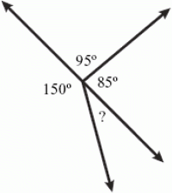
 | a. | 30º
 | b. | 50º
 | c. | 60º
 | d. | 85º

Correct Answer: | 30º
Explanation
A straight angle equals exactly 180º. Therefore, we can subtract 150º to find the measure of the missing angle: 180º - 150º = 30º. Angles / Geometry & Measurement

