Grade 6 MCA-III – Test #1 Answers

1. | 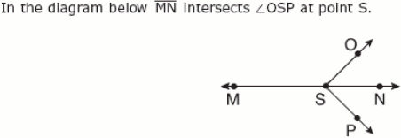  Which angles when combined have the same degree measure as a straight angle?
 | a.
 | b.
 | c.
 | d.

Correct Answer:

Explanation
Two angles are called supplementary angles if the sum of their degree measurements equals 180 degrees. When we combine angles OSN and OSM we get a straight line, which measures 180 degrees. Supplementary Angles / Geometry & Measurement

2. | Which pair of numbers are equivalent?
 | a. | 0.5, 1/5
 | b. | 0.06, 6/10
 | c. | 7/10, 0.07
 | d. | 8/100, 0.08

Correct Answer: | 8/100, 0.08

Explanation
To convert a fraction to a decimal, divide the numerator by the denominator: 8 ÷ 100 = 0.08. Therefore, 8/100 is equivalent to 0.08. Fractions, Decimals, and Percents / Number & Operation

3. | Chen records the number of crayons in her art supply box by color. The results are shown in the table below.  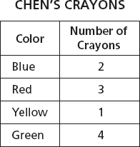  What is the ratio of the number of red crayons compared to the number of yellow crayons?
 | a. | 1:3
 | b. | 3:1
 | c. | 1:10
 | d. | 3:10

Correct Answer: | 3:1

Explanation
A ratio is a comparison of two similar quantities obtained by dividing one quantity by the other. Ratios are written with the : symbol. Since there are 3 red crayons and 1 yellow crayon in the box, the ratio of red to yellow crayons is 3:1. Ratios / Ratio & Proportion/ Geometry & Measurement

4. | A store sells potatoes in 5-pound bags for $2.29. Which of the following bags of potatoes would be the same price per pound?
 | a. | A 20-pound bag for $8.80
 | b. | A 2-pound bag for $1.02
 | c. | A 10-pound bag for $4.58
 | d. | A 7-pound bag for $3.01

Correct Answer: | A 10-pound bag for $4.58
Explanation
We need to divide 5 pounds by $2.29 to determine the price per pound: 2.29 ÷ 5 = 0.458 or $0.46 per pound. If we divide $4.58 by 10 pounds we get: 4.58 ÷ 10 = 0.458 or $0.46 per pound. Therefore, answer C is correct. Division / Number &Operation

5. | Mr. Jenkins wants to distribute 40 fliers. He has distributed 30 fliers so far. What percent of the total number of fliers has Mr. Jenkins distributed?
 | a. | 60%
 | b. | 70%
 | c. | 75%
 | d. | 80%

Correct Answer: | 75%

Explanation
Let x = the percent, and write the following equation: 30 = x% of 40. We can adjust this equation to read as follows: 30 = x/100 x 40. If we do the multiplication we get: 30 = 40x/100. We can place a 1 under the 30 to get: 30/1 = 40x/100. Now we can cross-multiply: 40x = 3,000. If we divide both sides by 40 we get: x = 75%. Percents / Number & Operation

6. | A pan used to bake bread is in the form of a rectangular prism. The pan is 9 inches long, 5 inches wide, and 3 inches deep. What is the volume of the pan?
 | a. | 17 in.³
 | b. | 45 in.³
 | c. | 135 in.³
 | d. | 945 in.³

Correct Answer: | 135 in.³

Explanation
The volume V of any right prism is the product of B, the area of the base, and the height h of the prism. The base B = l x w of the base. If we find the area of the base of this rectangular prism we get: 9 x 5 = 45. If we multiply the area of the base by the height we get: 45 x 3 = 135 in.³. Volume of Prisms / Geometry & Measurement

7. | What is the area of triangle HJK in square units?  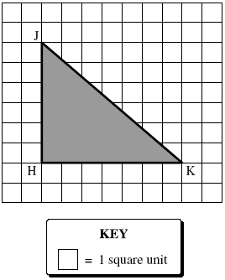
 | a. | 13 square units
 | b. | 21 square units
 | c. | 36 square units
 | d. | 42 square units

Correct Answer: | 21 square units

Explanation
The area of a triangle is 1/2 × b × h, where b is the length of the base of the triangle, and h is the corresponding height. By looking at this triangle we can see that the base is 7 units and the height is 6. If we plug these number into the formula we get: A = 1/2 x 7 x 6 or A = 21 square units. Area of a Triangle / Geometry & Measurement

8. | Ted collected 22 pounds of aluminum cans. How many ounces of aluminum cans did he collect?
 | a. | 6 oz
 | b. | 38 oz
 | c. | 352 oz
 | d. | 220 oz

Correct Answer: | 352 oz

Explanation
Since there are 16 ounces in 1 pound, we can multiply that number by 22 pounds to find out how many ounces of cans Ted collected: 16 x 22 = 352 ounces. The English System of Measurement / Geometry & Measurement

